**A Project Report**

on

**MEETUP**

An app based on common interest

* **Abstract**

I was interested in this project because I wanted to brush up my android development skills and to learn new things through this internship.

Till now there is no such application exist which comprises of news and chatting facility in one app. So MEETUP application overcome this limitation and provides both facilities.

Methodology to develop this application is adding news and chatting facility by considering people’s interest.

Impact of MEETUP application is, people can share their valuable knowledge with each other, gain knowledge according to their interest and can maintain healthy social relations with each other.

* **Table of Content**

|  |  |  |
| --- | --- | --- |
| Sr. No | Topic | Page No. |
| 1 | Introduction and Objective | 3 |
| 2 | Proposed System with Architecture | 4 |
| 3 | Methodology | 6 |
| 4 | Features | 9 |
| 5 | Software Overview and Requirements | 10 |
| 6 | Future Enhancement | 12 |
| 7 | Conclusion | 13 |
| 8 | References | 14 |
| 9 | Acknowledgement | 15 |
| 10 | Certificate | 16 |

* **Introduction**

MEETUP is an android application, which can help people to get so much information about their interest and can maintain a healthy social relation through instant messaging facility. MEETUP is combination of News application + Social Media application through which users can get all news according to their interest throughout the world. Users can share their valuable knowledge with each other and able to share their feelings and emotion with friends viasocial media functionality. Users are able to make friends and able to talk with them. MEETUP is a simple application which will be easily adaptable by users as it is user friendly.

* **Objective**
* To develop an interactive android app which provides :
  + Latest News Update
  + Chatting
  + Information or Content Sharing
* **Proposed System with Architecture**

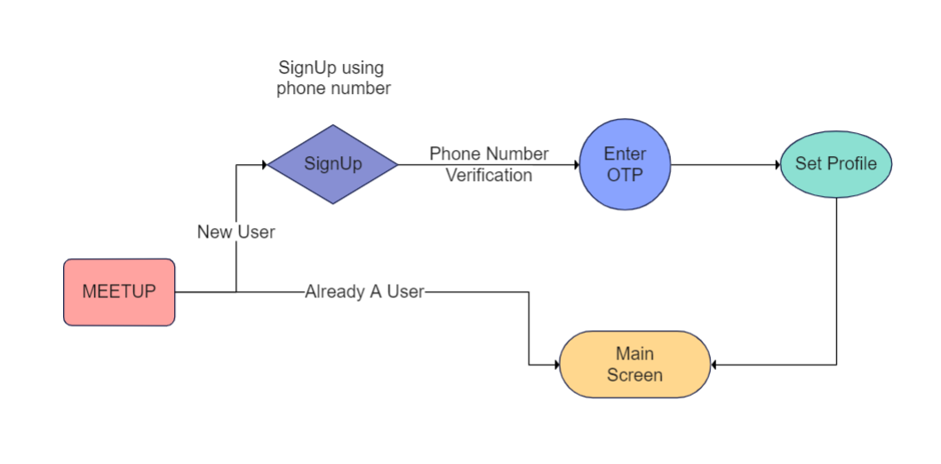

* If user is not registered on application then first he/she has to verify their phone number and have to set their profile. After that they will become an authorized user of app and can enjoy it’s features.
* If user is already an authorized one then he will be taken on Main Screen

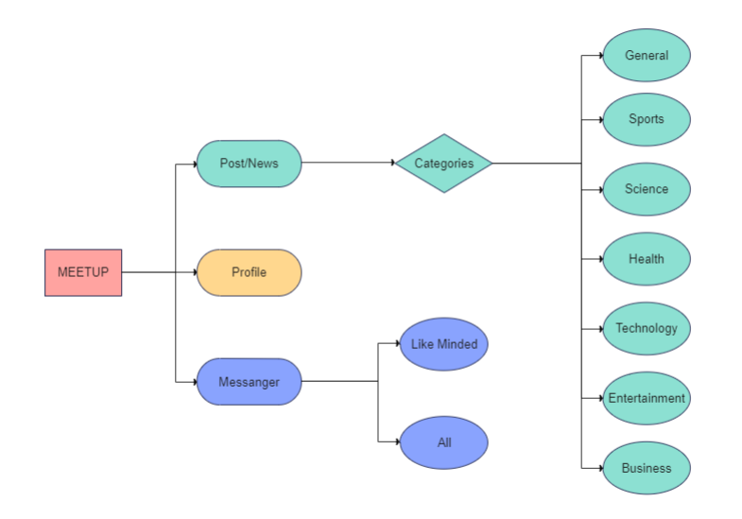

Above context diagram shows the different modules of applications

* There are three main activities News, Profile and Messenger
* News activity contains 7 different categories of news, each fragment contains news related to their category.
* In profile activity, users can set or update their profile by adding their names, profile pictures and their interest.
* In messenger activity user can chat with like-minded people or can chat with all the users who has their account on this application.
* **Methodology**

The user interact with application using UI. Following are

the screenshots of UI present on the app.

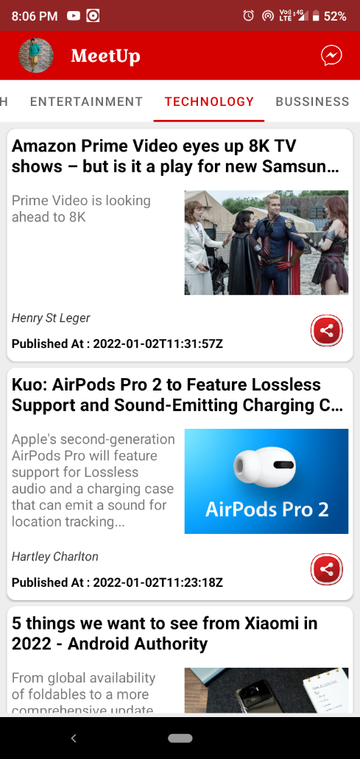 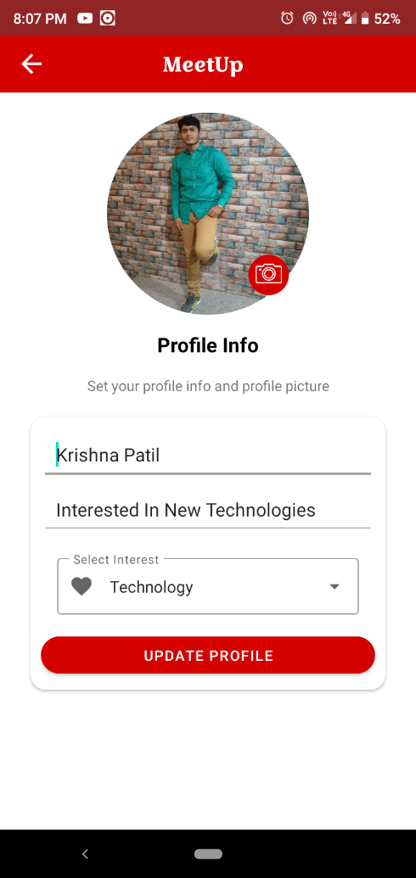

MainActivity Profile

* MainActivity contains news related to different categories. User can tap on post or news and it will be open in web-view activity. User can share a specific news with other users though share button.
* In profile activity user can set or update their profile by updating name, about their self, interest and profile picture.

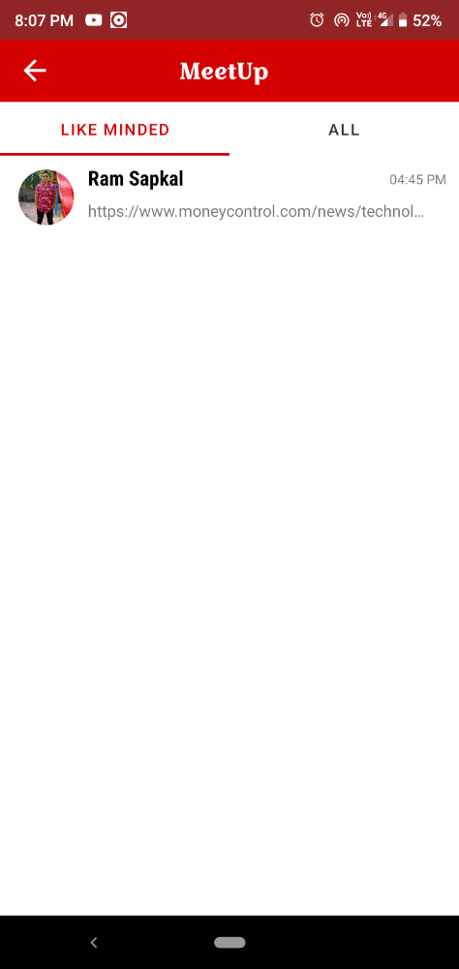 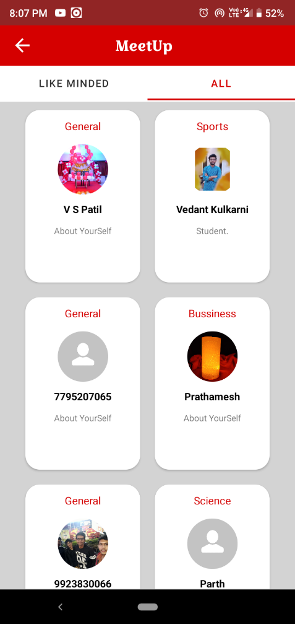

List of like-minded people List of all users

* List of like-minded people contains all the users who has similar interest like you. You can easily chat with them by tapping on their view.
* List of all users contains all the users who has their accounts on this application. You can chat with them by tapping on their view.

 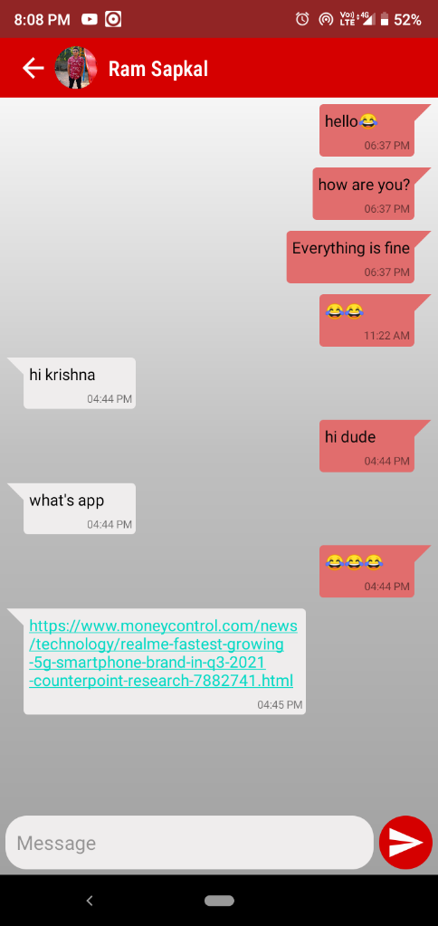

Web View Activity Chatting Activity

* Web View Activity displays the content of the selected news. From their user can read entire news.
* In Chatting activity, users can chat with each other by instant messaging facilities. Users can send links and can open those link from chatting activity.
* **Features**
* MEETUP app provides following features

1. Simple and Friendly User UI
2. Secure Login.
3. Content Sharing Method.
4. Latest News and Current Affairs.
5. 7 Different Categories of Interest.
6. Options to interact with content.
7. Social Media Integration.

* **Software Overview and Requirements**
* **Software**
* **Tools :**

1. **Android Studio :** Android Studio is the official Integrated Development Environment (IDE) for Android app development, based on [IntelliJ IDEA](https://www.jetbrains.com/idea/). On top of IntelliJ's powerful code editor and developer tools, Android Studio offers even more features that enhance your productivity when building Android apps
2. **Firebase :** Firebase is a development platform known originally for its realtime database that’s still at its core a multi-node, key-value database optimized for synchronizing data, often between user machines or smartphones and centralized storage in the cloud. It’s designed to make life easier for developers by handling much of the pushing and pulling of data. That relieves app developers of the programming burdens associated with managing versions or locations. They can write the new bits to Firebase and the data will be consistent throughout the system.
3. **JDK :** The Java Development Kit (JDK) is one of three core technology packages used in Java programming, along with the JVM (Java Virtual Machine) and the JRE (Java Runtime Environment).

* **Technology :**
  1. **Java :** One of the most widely used programming languages, Java is used as the server-side language for most back-end development projects, including those involving big data and Android development. Java is also commonly used for desktop computing, other mobile computing, games, and numerical computing.
* **API’s :**
  1. **News API :** News API is a simple JSON-based REST API for searching and retrieving news articles from all over the web. Using this, one can fetch the top stories running on a news website or can search top news on a specific topic (or keyword).
* **Requirements**

1. Android API level 24 and higher.
2. Standard Development Kit (SDK).
3. Permissions
   * INTERNET
   * ACCESS_NETWORK_STATE
   * ACCESS_WIFI_STATE

* **Future Enhancement**

There is always a room for improvements in any software package, however good and efficient it may be done. But the most important thing should be flexible to accept further modification. Right now we are just dealing with text communication and unpaid version of News API. In future this application may be extended to include features such as:

* File transfer : this will enable user to send files of different formats to others via the chat application.
* Voice chat : this will enhance the application to a higher level where communication will be possible via voice calling as in telephone.
* Video call : this will further enhance the feature of calling into video communication.
* **Conclusion**

MEETUP is a powerful tool which can help you to enhance knowledge about various categories such as Science, Technology, Business and Health. Can make you to be up to date. MEETUP can increase your visibility, enhance relationship, and establish two way communication between users. MEETUP will keep users in touch with friends and extended family, enhance social life and maintain healthy social relation.

* **References**

1. https://developer.android.com/docs
2. https://firebase.google.com/docs
3. https://newsapi.org/docs

* **Acknowledgement**

If words are considered as a symbol of approval and token of appreciation then let the words play the heralding role expressing my gratitude.

The satisfaction that accompanies that the successful completion of any task would be incomplete without the mention of people whose ceaseless cooperation made it possible, whose constant guidance and encouragement crown all efforts with success. I am grateful to my project manager Mr. Vishnu Vardhan sir for the guidance, inspiration and constructive suggestions that helpful me in the preparation of this project. I also thank to EXPOSYS DATA LABS for giving me opportunity for this great internship.

Krishna Vijay Patil.

**CERTIFICATE**

**This is to certify that the project entitled as**

**MEETUP**

An app based on common interest

Is the bonfire work of

**Krishna Vijay Patil**

in partial fulfillment of the requirements for the award of Bachelor in Technology in Information Technology at the Government College of Engineering Aurangabad is an authentic work carried out by him under our supervision and guidance.

Project Manager EXPOSYS DATA

LABS

Thank You